HYDRO-MAX
HM 1600

HYDRAULICALLY-DRIVEN

AC GENERATOR

BY 

120 /
240 V
60 Hz

16000
Watts
1 Phase
\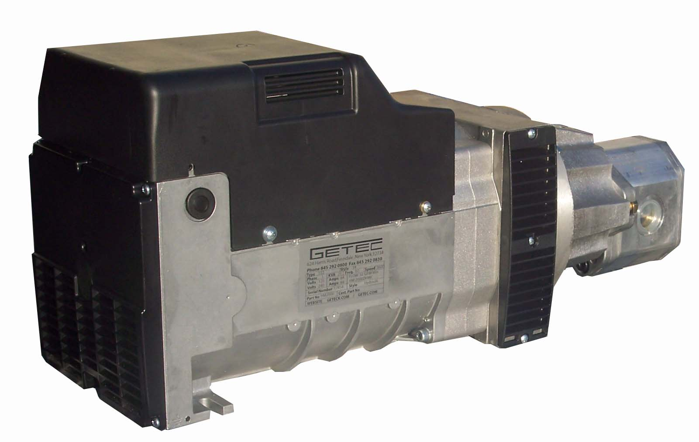
Optional Panel

QUALITY FEATURES
Brushless AC Generator |  | Includes Pressure Compensating Flow Regulator
Maintenance Free Design |  | Lifetime Guaranteed Alignment

SPECIFICATIONS
Flow = | 19 GPM |  | Volts = | 120 or 120/240
Pressure = | 2400 PSI |  | Amps = | 150 @ 120
Speed = | 3600 RPM |  | Watts = | 16000 Continuous
Weight = | 135 Lbs |  | Power Factor = | 1.0
Dimensions = | 9” W * 12.5” H * 29” L |  | Temperature Rating = | 105 C
FERNDALE, NY 12734
(845)-292-0800
http://www.getec.com
GETECK.COM

